Personal Health History

Patient’s Name _________________________________________ Date of Birth _____/_____/_____ Date __________________

The following form is to be completed prior to your consultation and emailed to the above contact details. Upon receiving the questionnaire, we will contact you via email to schedule your first consultation. Please complete the health history questionnaire. If you have any test results, etc. please feel free to attach copies along with any pertinent information not covered here. All information will be kept strictly confidential. Please check the degree of all conditions you currently have or have had. To be responsible for your case, we need your complete health history.

O = Occasional F = Frequent C = Constant

O F C

Muscle / Joint
Arthritis
Bursitis
Foot trouble
Hernia
Low back pain
Lumbago
Neck pain, stiffness
Pain between shoulders

General
Allergy
Chills
Convulsions
Dizziness
Fainting
Fatigue
Fever
Headache
Loss of sleep
Loss of weight
Nervousness, depression
Neuralgia
Numbness
Sweats
Tremors

O F C

Skin
Boils
Bruise easily
Dryness
Hives or allergy
Itching
Skin eruptions (rash)
Varicose veins

Pain or numbness in
Shoulders
Arms
Elbows
Hand
Hips
Legs
Knees
Feet
Painful tailbone
Poor posture
Sciatica
Spinal curvature
Swollen joints

O F C

Cardiovascular
Hardening of arteries
High blood pressure
Low blood pressure
Pain over heart
Poor circulation
Rapid heartbeat
Slow heartbeat
Swelling of ankles

Respiratory
Chest pain
Chronic cough
Difficult breathing
Spitting up blood
Spitting up phlegm
Wheezing

Are you pregnant? Yes No
If yes, how many months?__________

Describe your problem if scoliosis state the degree and type of curve:

How long have you had this condition? Is it getting worse? Yes No
Does it bother your (check appropriate box): Work Sleep Other (please specify)
What seemed to be the initial cause?
Are you under the care of a physician? Yes No If yes, for what reason?
Have you been hospitalized in the last 5 years? Yes No If yes, for major surgery? Yes No for serious injury? Yes No
Have you had any mental or emotional disorders? Yes No If yes, when?
Indicate the drugs do you now take? Birth control pills Tranquilizers Pain Killers Other (specify)
Do you wear: heel lifts? sole lifts? inner soles? area supports? negative heels? platform shoes?
How is most of your day spent? standing sitting walking other (specify)

Have you ever: Yes No If yes, briefly explain.
- had a broken bone?
- been hospitalized?
- had strains or sprains?
- used a cane, crutch or other support?
- been struck unconscious?
- been hospitalized for other than surgery?

Do you:
- take minerals, herbs or vitamins?
- think you need minerals, herbs or vitamins?
- have any drug allergy?

When did you last have: Never 0-6 months. 6 -18 months. Longer
- spinal x-ray?
- spinal examination?
- physical examination?

Please list any other health conditions you have been treated for, or surgery you have had in the last ten years.

FAMILY HEALTH HISTORY: Information about your immediate family members, brothers, sisters, parents, and grandparents will give us a better understanding of your total health picture.

RELATIONSHIP | PRESENT AND PAST HEALTH PROBLEMS

PATIENTS HEALTH HISTORY: Information about your history living with scoliosis. Include information about when it was first diagnosed, how it has progress, symptoms related or unrelated to scoliosis, types and dates of treatment you have and anything else not discussed above which you would like to inform Dr. Kevin Lau.

Draw your scoliosis if possible.
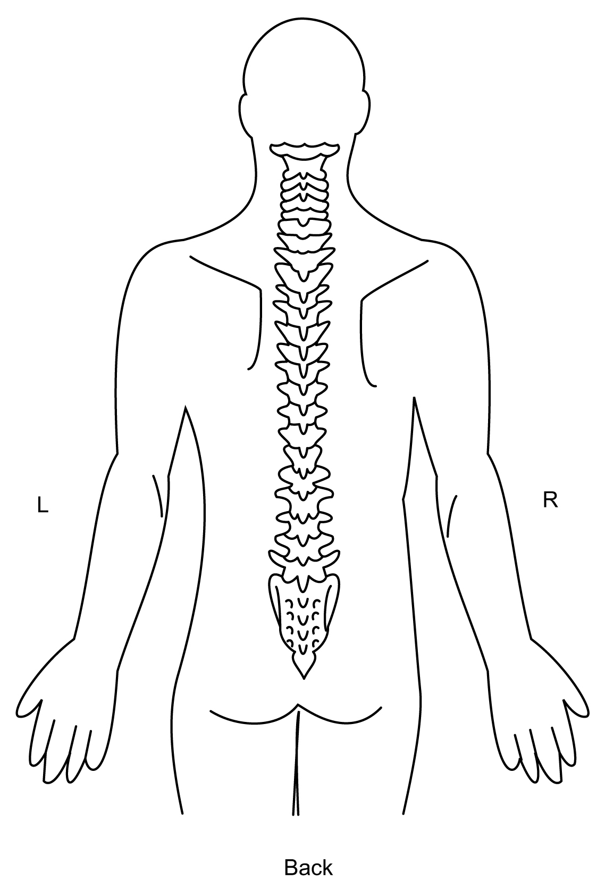
Please mark your areas of pain on the figures below. 